**John Earl Wolfe and Family**

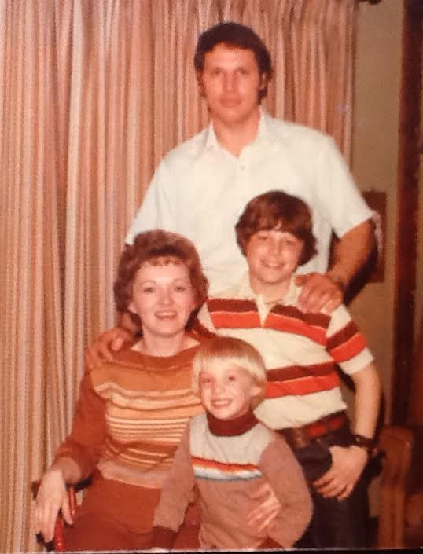

Linda Evans Wolfe, Aaron John, John Earl, Tyler Wolfe – 1978

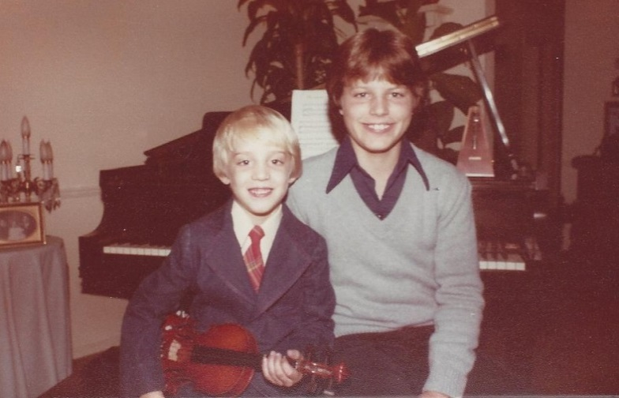

Aaron John & Tyler Evans Wolfe, sons of John and Linda Wolfe - 1979